Use Azure Pricing Calculator (Step-by-Step Guide)
The Azure Pricing Calculator helps you estimate the cost of Azure services before deploying them.

Step 1: Open Azure Pricing Calculator
- Open a browser.
- Go to the Azure Pricing Calculator website.
https://azure.microsoft.com/en-in/pricing/calculator/
- The calculator page will display a list of Azure services.
- Click on login.
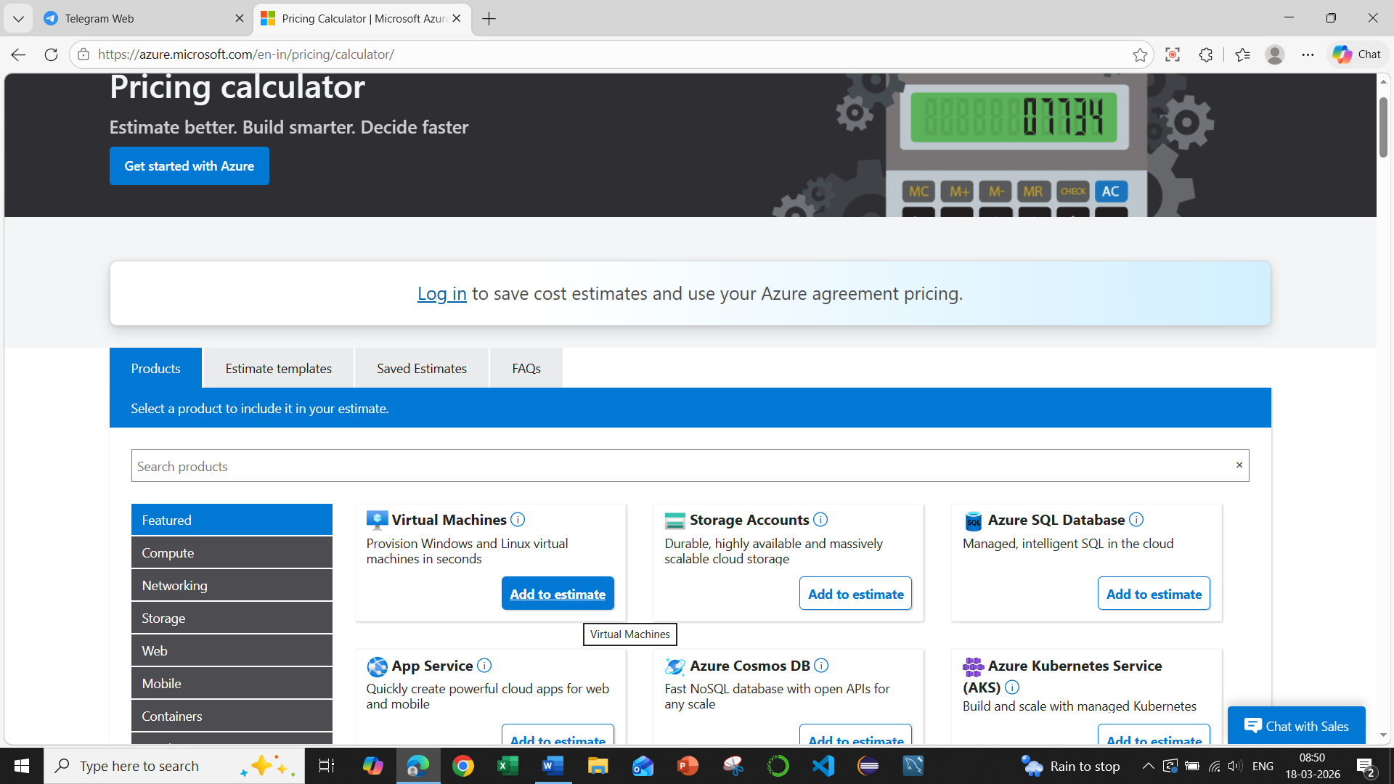

Step 2: Select a Service
- In the search bar, type the service you want to estimate.
Examples:
  - Virtual Machines
  - Storage Accounts
  - App Services
- Click Add to Estimate for the required service.
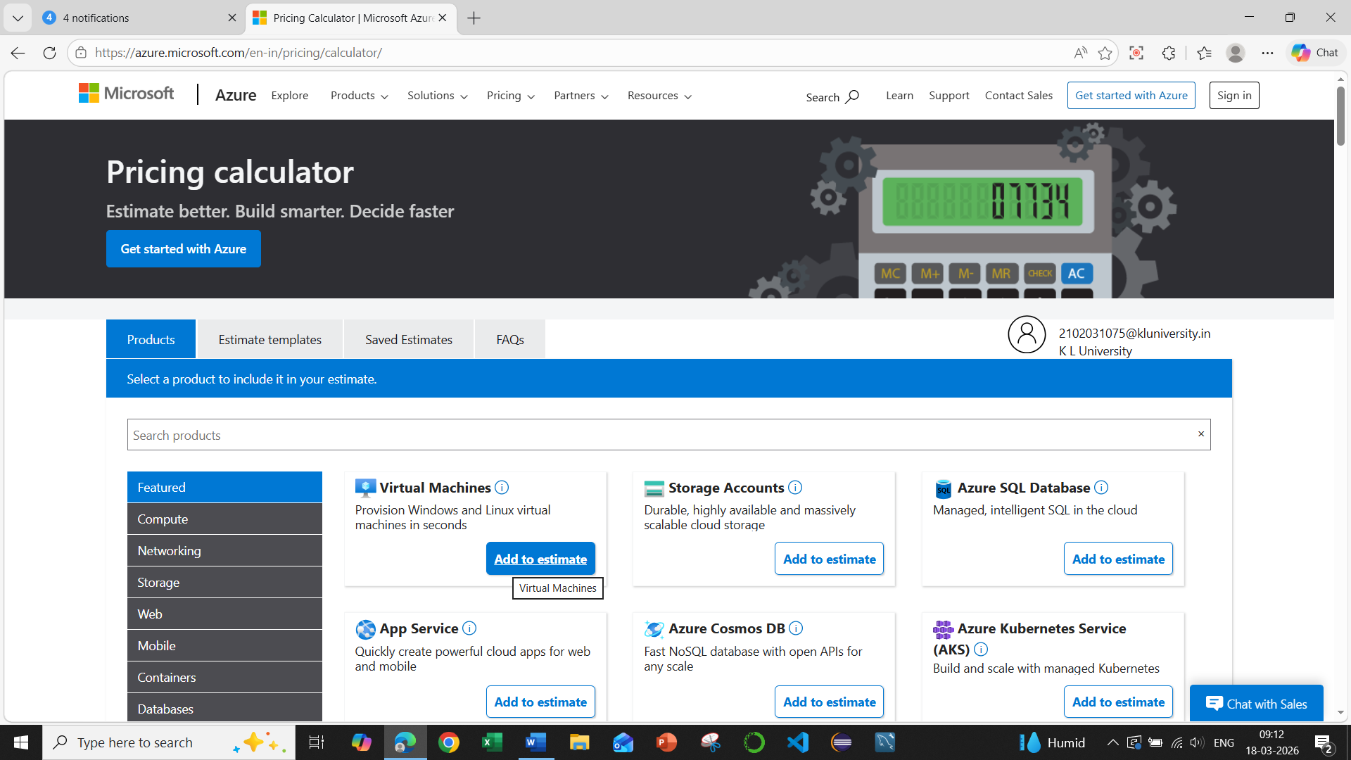

Step 3: Configure Service Details
After adding the service, configure its settings. Go down in the same page to view Your Estimate.
Example for Virtual Machine:
- Region: East Asia / India
- Operating System: Windows or Linux
- Instance Type: Standard B1s / B2s etc.
- Number of Instances: Example 1
- Hours per Month: Default 730 hours
The calculator will automatically show the estimated monthly cost.
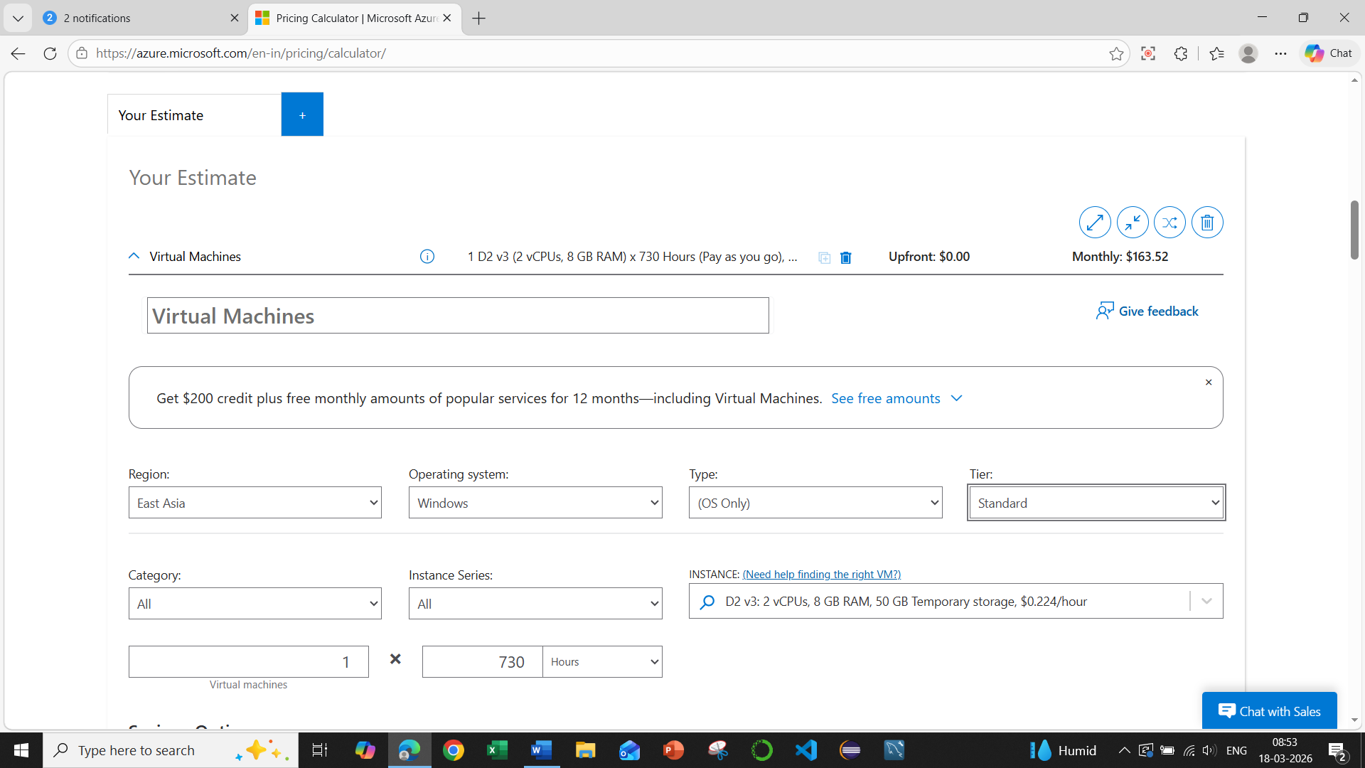

Step 4: Add More Azure Services
- Click + Add Products.
- Add other services such as:
  - Storage
  - SQL Database
  - Bandwidth
Each service will be added to the estimate list.
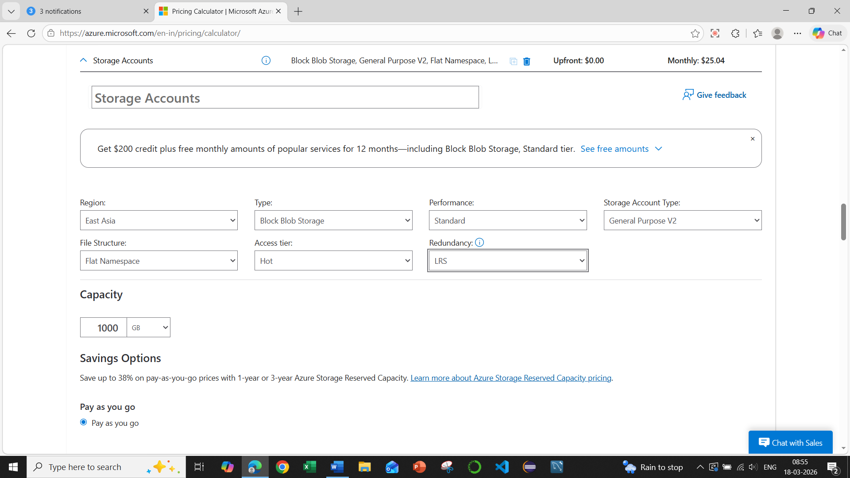
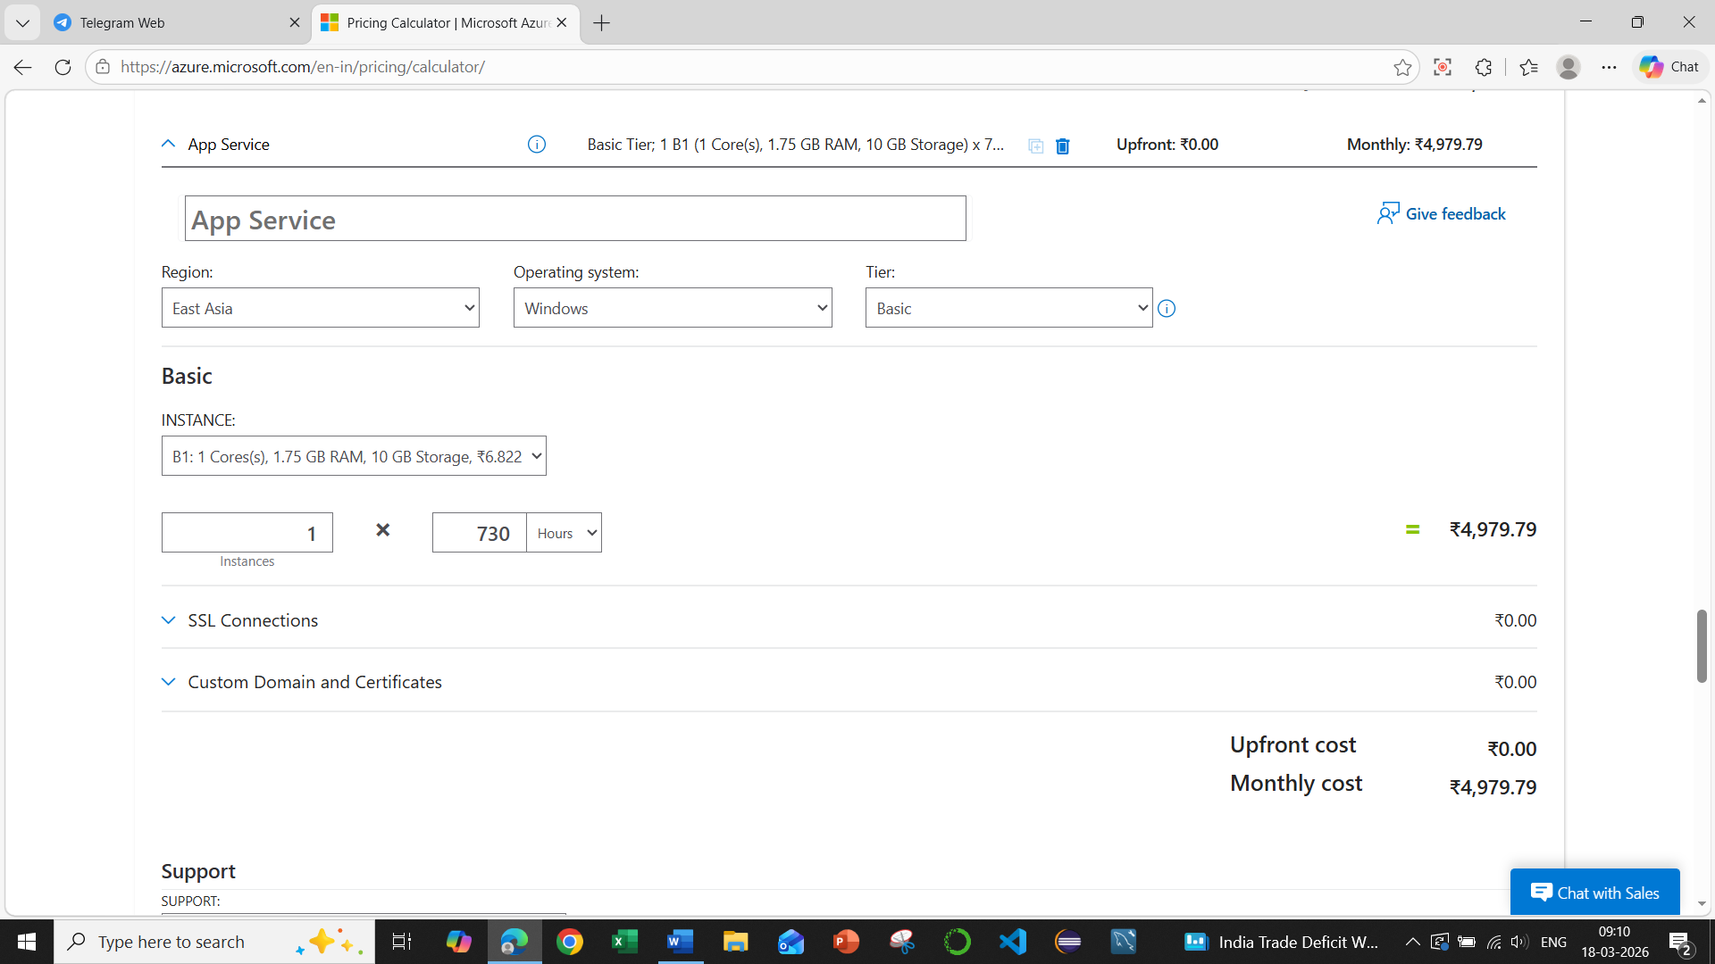

Step 5: View Total Estimated Cost
At the bottom or side panel you will see:
- Total Monthly Cost
- Service-wise cost breakdown
This helps you understand how much your Azure solution may cost.
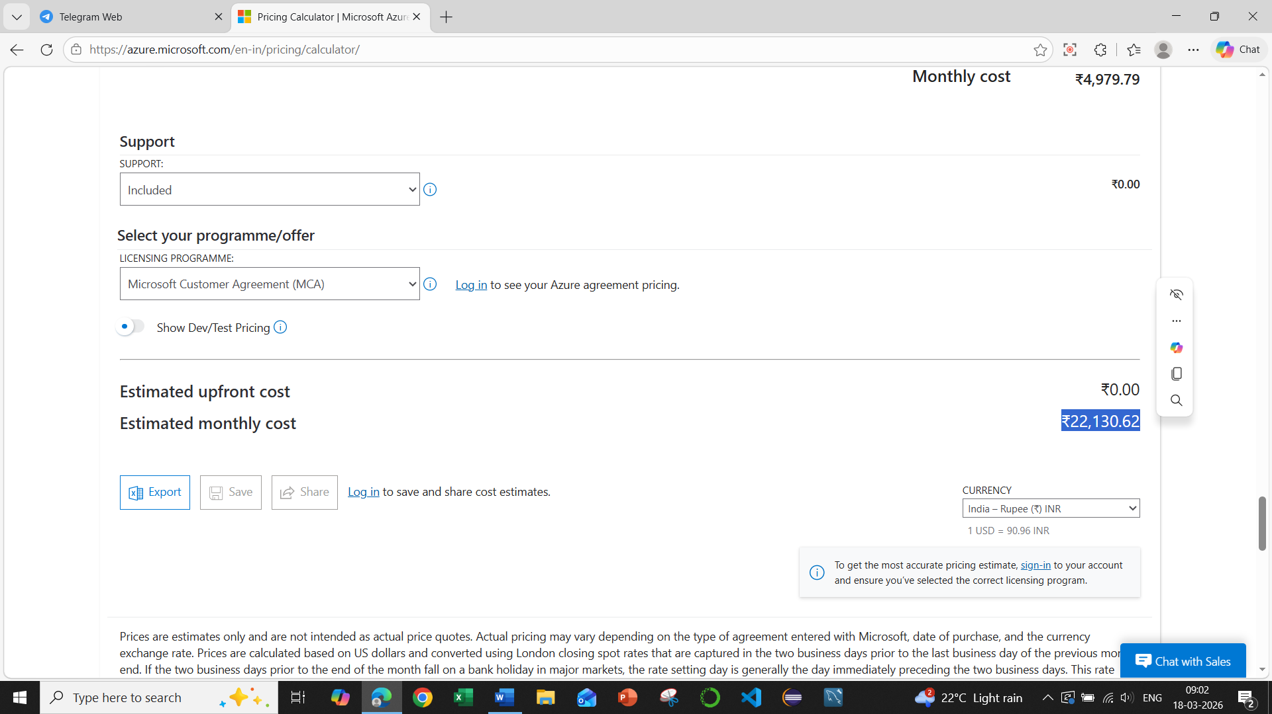

Step 6: Save or Export the Estimate
You can also:
- Save the estimate
- Export to Excel
- Share estimate link
These options help in project planning or cost comparison.
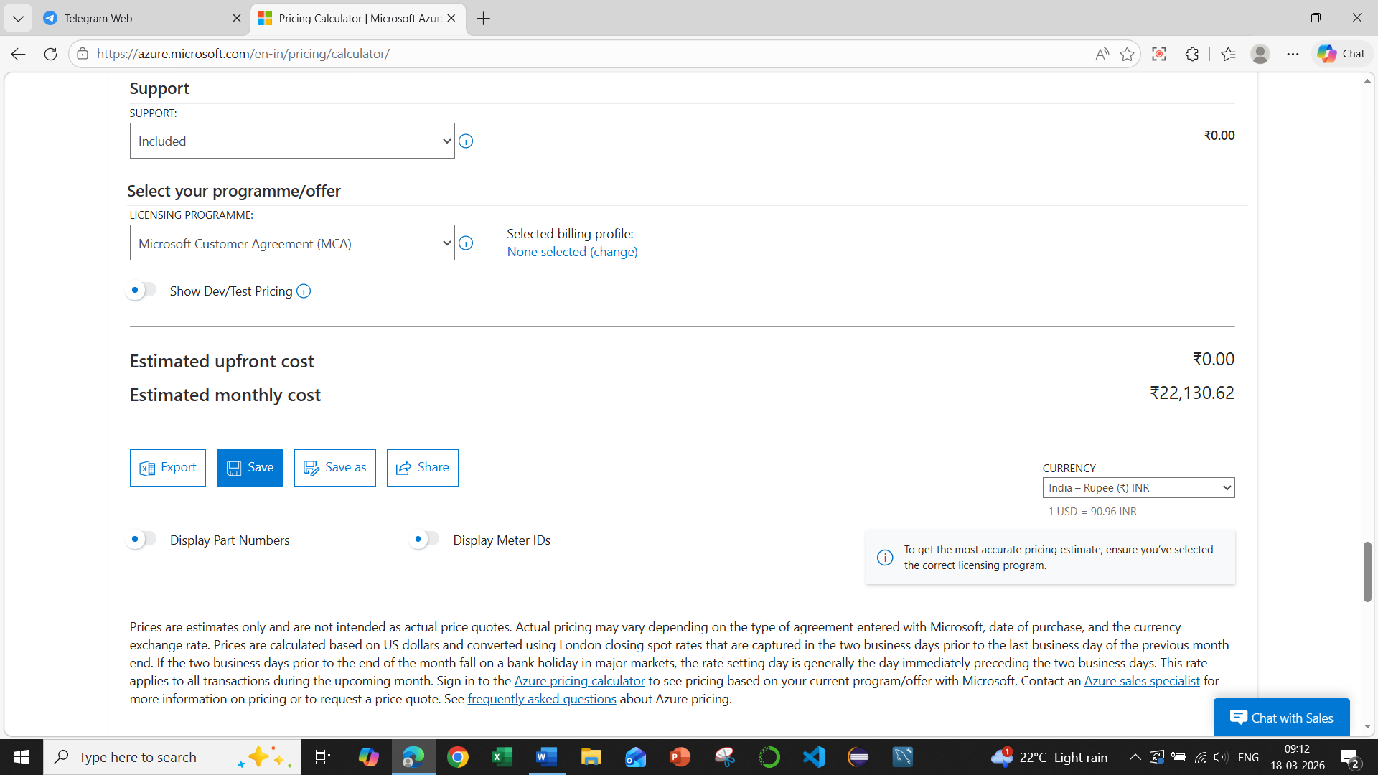
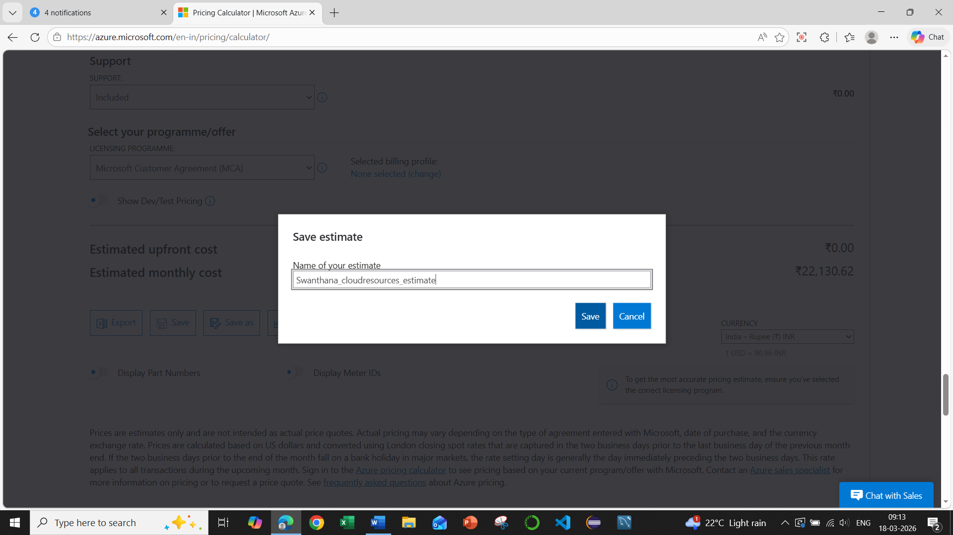
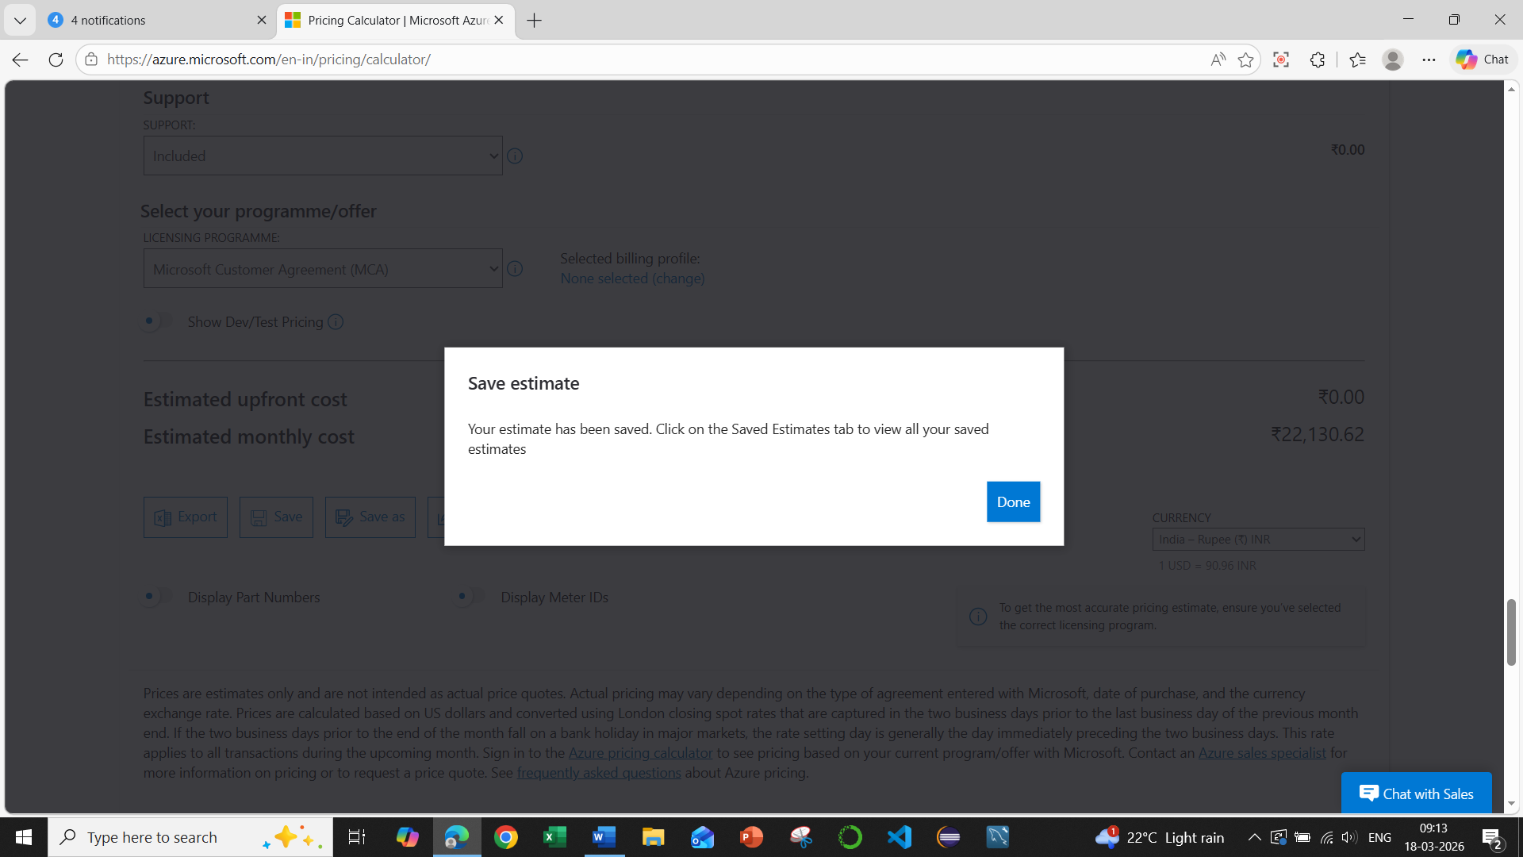
Click on Done.
Then click on Export
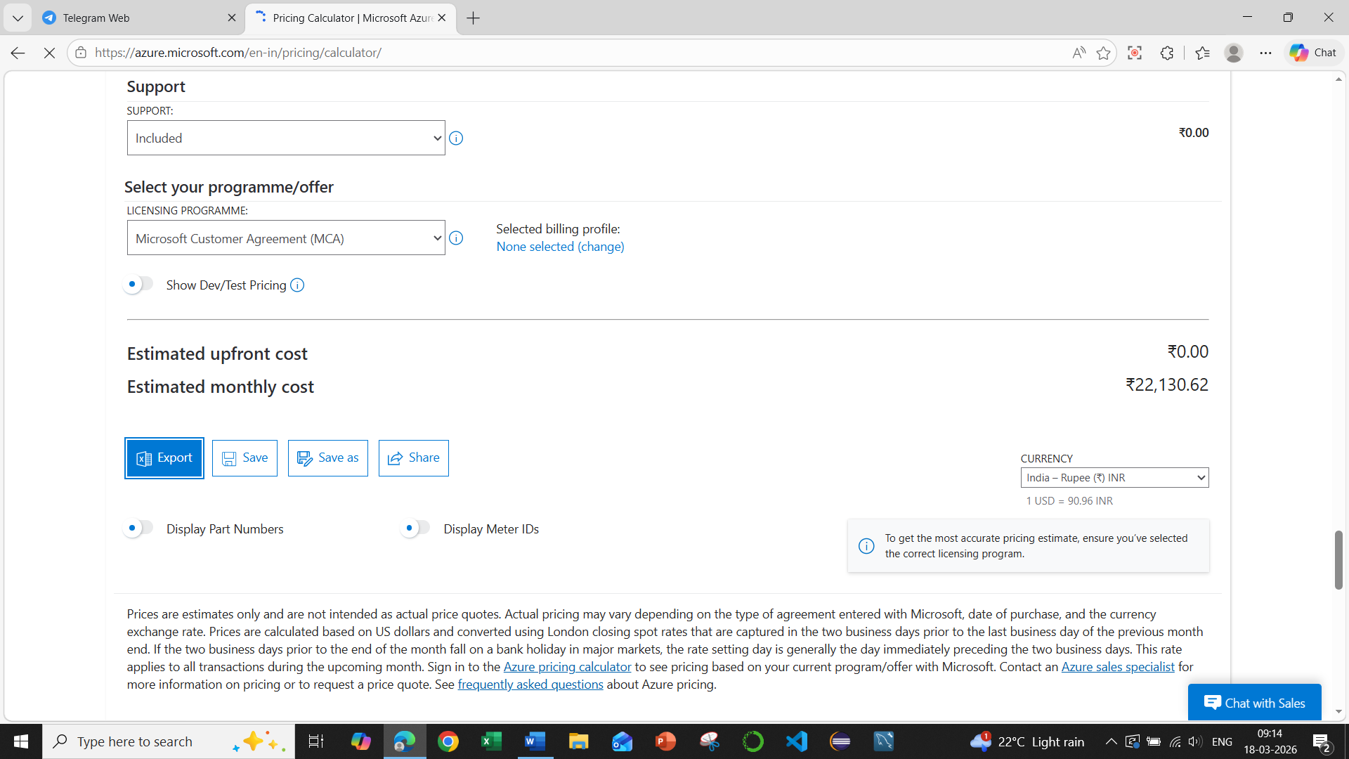
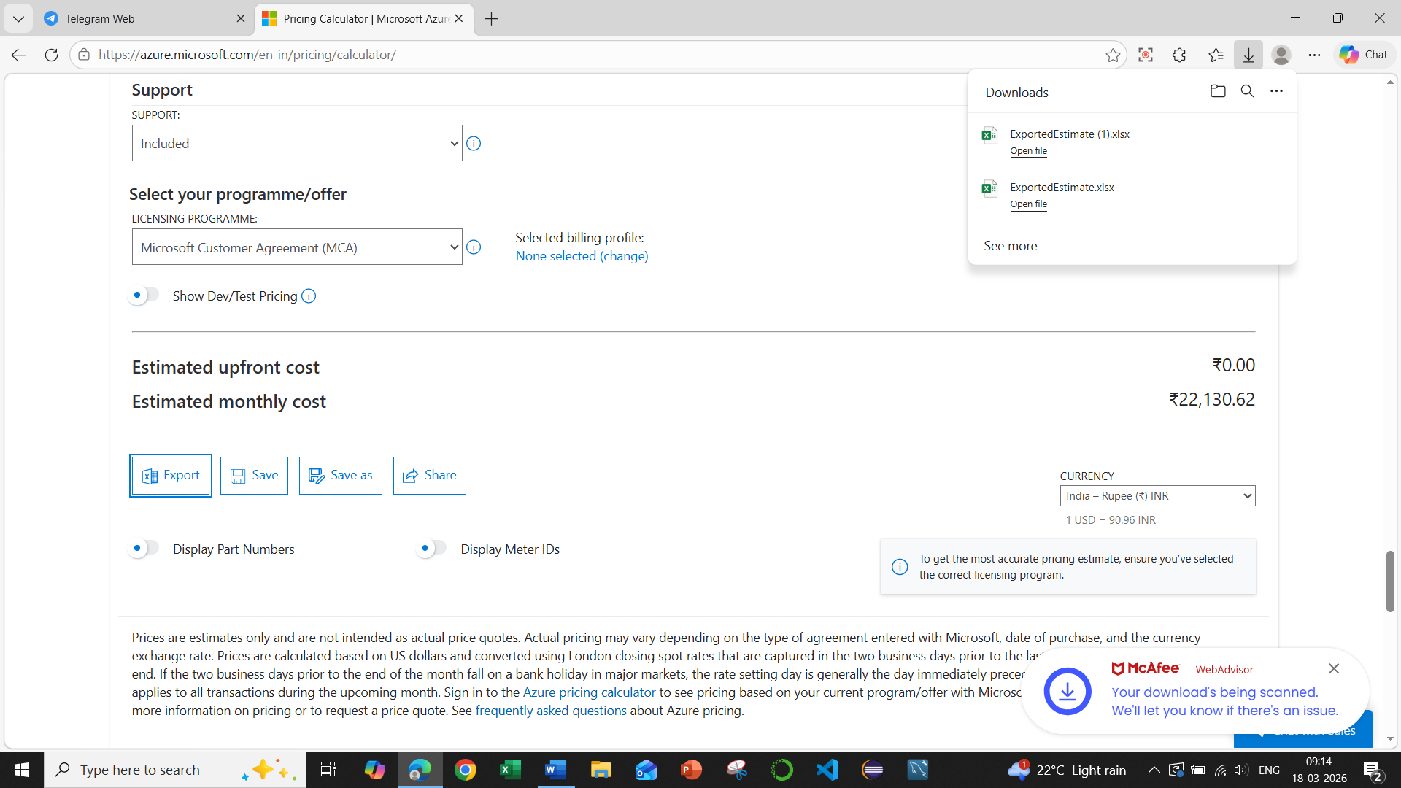
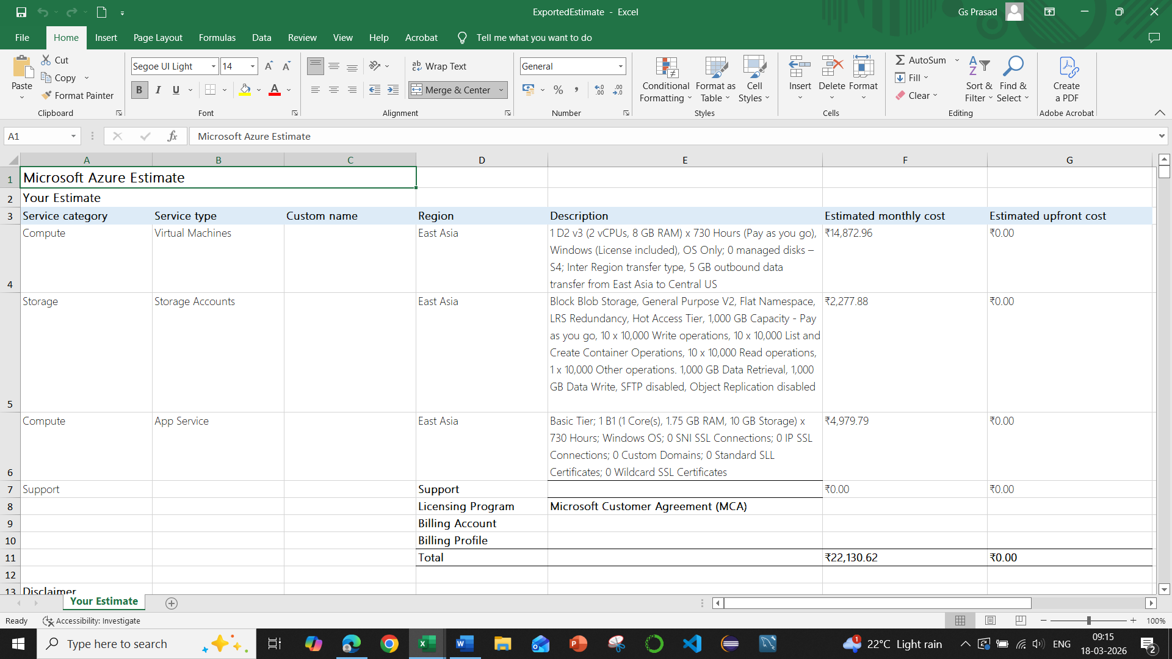

💡 Why Azure Pricing Calculator is used
- Estimate cloud deployment cost
- Compare different Azure services
- Plan budget for projects
- Avoid unexpected billing

